**Figure 1**. Distribution of *Quercus pyrenaica* forests in the Iberian Peninsula (a) and in Sierra Nevada mountain range (b). Different colors indicate oak-population clusters identified in Sierra Nevada (Pérez-Luque et al. 2015). For each population, a grid with the MODIS pixels is shown (see Material and methods). Detailed location of the dendroecological sampling sites: northern (San Juan, SJ) (c), and southern ones (Cáñar: CA-Low and CA-High) (d). Color orthophotography of 2009 from Regional Ministry of the Environment.

**Figure 2.** ***a)*** EVI standardized anomaly during the period 2000-2016 for northern and southern populations. Error bars show standard error. See main text for details on EVI calculation. ***b)*** Percentage of pixels showing browning, greening or no changes during the 2005 and 2012 drought events according to EVI standardized anomalies. See main text for an explanation of greening and browning.

**Figure 3.** Basal Area Increment (BAI) chronologies of *Q. pyrenaica* for northern population (SJ; *red*) and southern ones: low-elevation (CA-Low; *green*) and high-elevation (CA-High, *blue*) sites. Shading areas correspond to standard error of the mean. Number of series is displayed in the upper plot. Only years replicated with # series > 5 are shown. Linear trends since 1975 are indicated for all sites (numbers indicate $r^{2}$ values; asterisks indicate significant linear trend, *p < 0.001*).

**Figure 4.** Comparison of median growth change ($GC$) following Nowacki and Abrams (1997) for *Q. pyrenaica* sites. Dashed black lines indicate a threshold of 50% of GC (see Material and methods). Note that y-axes do not correspond in all of the three panels for the sake of clarity. Error bars indicate standard error.

**Figure 5.** Resilience metrics of tree-growth for eight severe drought events since 1950 (see main text for details) as a function of drought severity. *Left*: Resistance (*Rt*); *Center*: Recovery (*Rc*); *Right*: Resilience (*Rs*). Points indicate resilience metrics for oak populations: SJ (*red*), CA-High (*blue*) and CA-Low (*green*). Resilience metrics were computed for each population (sample depth > 10) and drought event. Gray lines represent overall relationships for each Resilience metrics.

**Figure 6.** Comparison of the response of *Q. pyrenaica* forests to drought in terms of resistance, recovery, and resilience of greenness (a) and tree growth (b). For EVI, northern populations (*red circle*) were compared with southern ones (*green circle*). For BAI, the more xeric northern population (San Juan, SJ; *red circle*) was compared with the two southern populations, Cáñar-High (CA-High; *blue circle*) and Cáñar-Low (CA-Low; *green circle*). Different letters indicate significant *post hoc* differences between groups (see Material and methods for details).

**Figure 7.** Correlation coefficients found by relating tree-ring residual chronologies (RWI) of *Q. pyrenaica* and monthly climatic data: precipitation and 6-month SPEI (a), minimum (b) and maximum (c) temperatures. *green* bars: northern site (SJ); *light blue* bars: low-elevation southern site (CA-Low); and *dark blue* bars: high-elevation southern site (CA-High). Asterisks indicate significant ($P<0.05$) correlation coefficients.

**Figure 1**

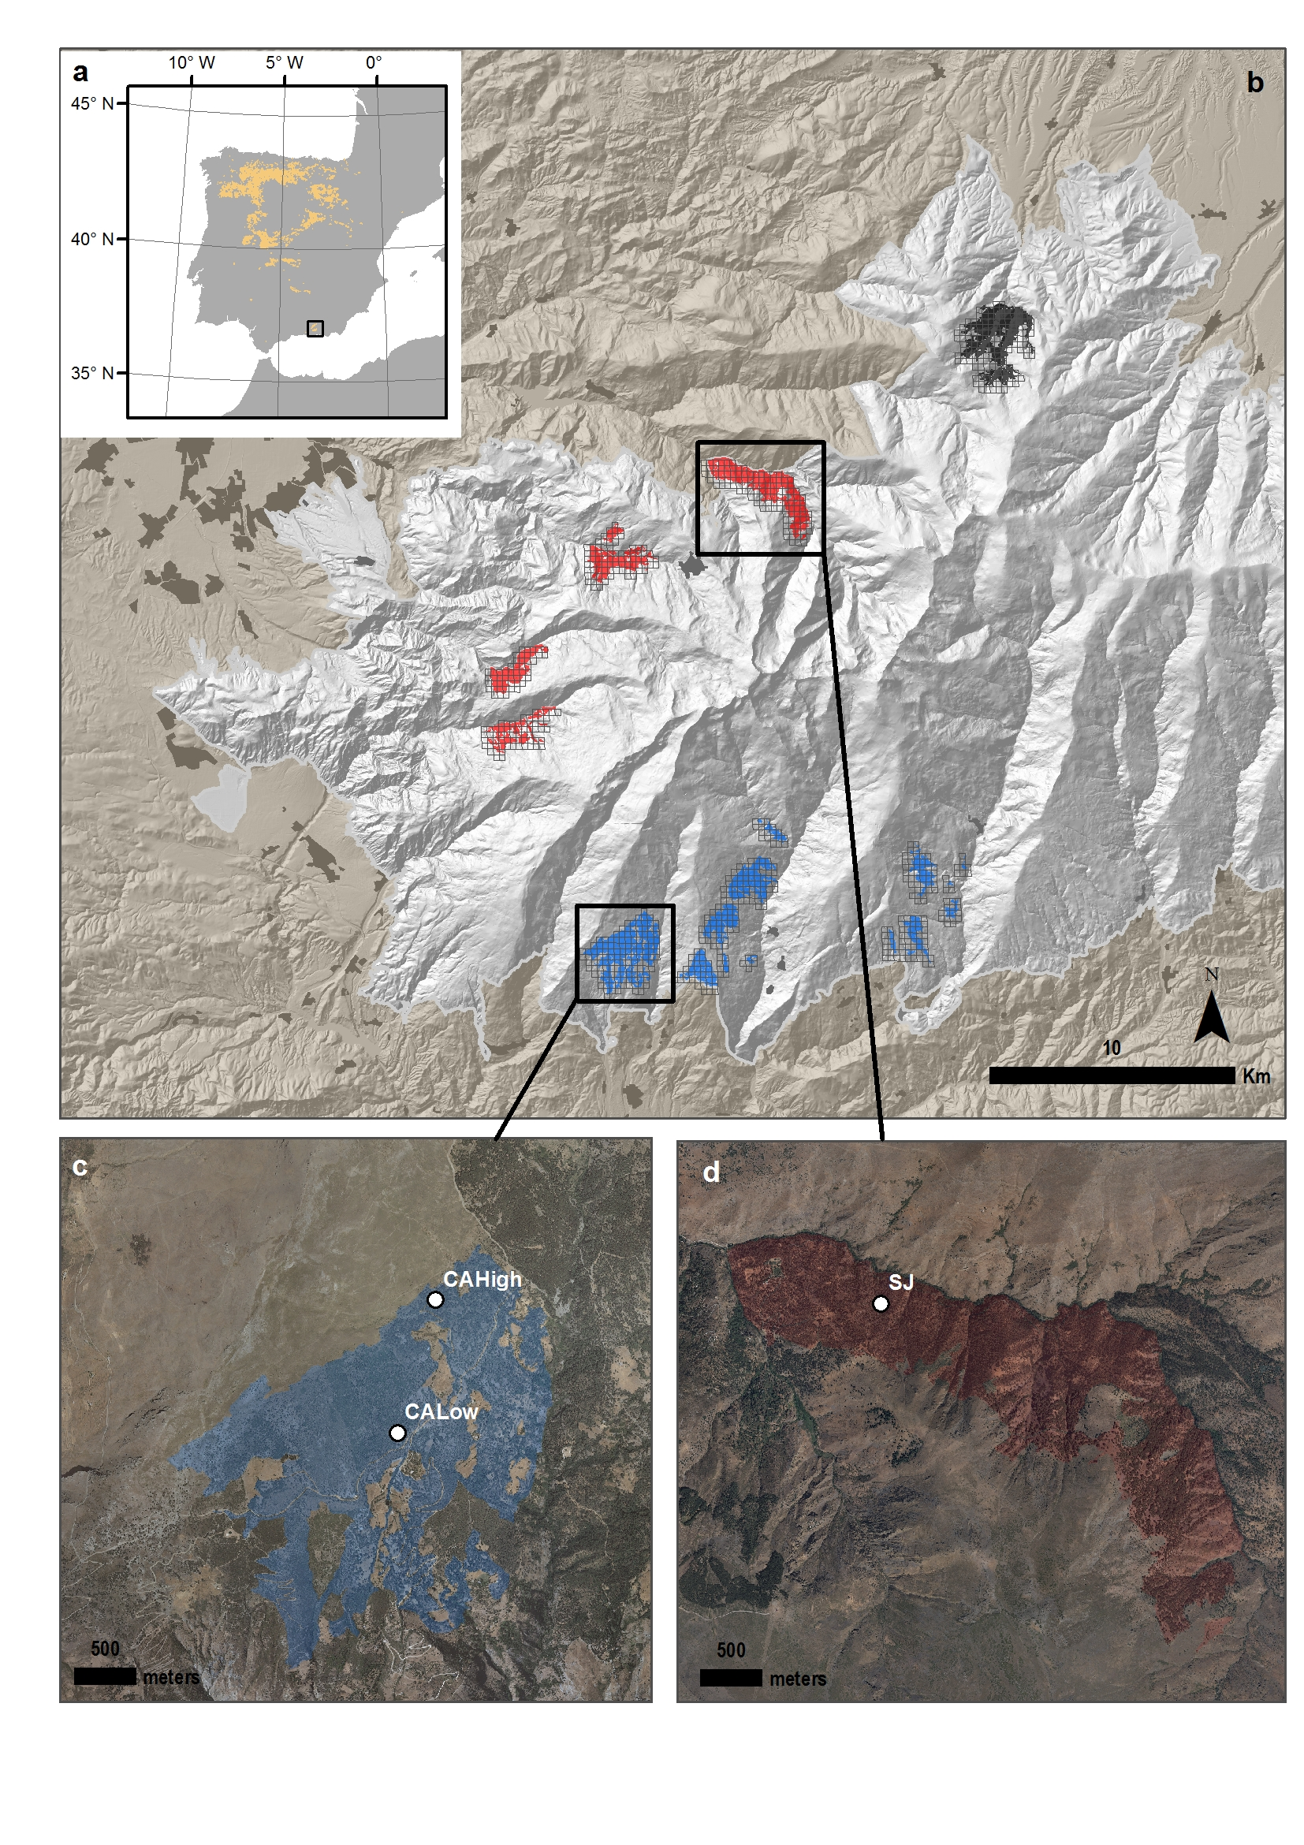

**Figure 2**

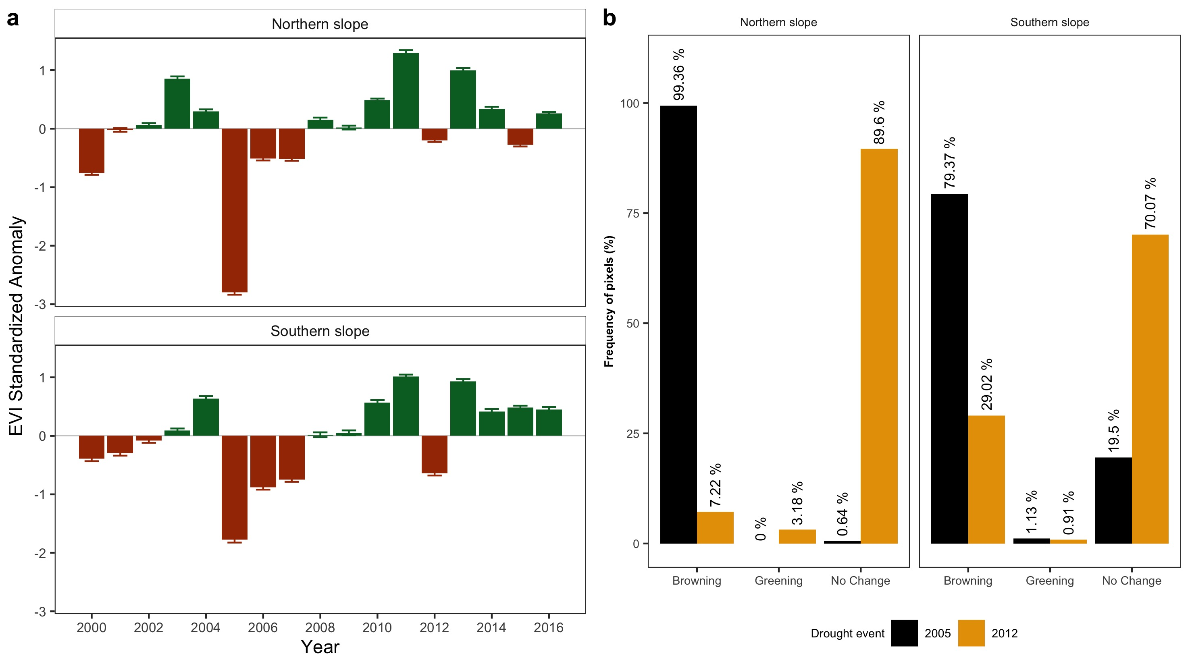

**Figure 3**

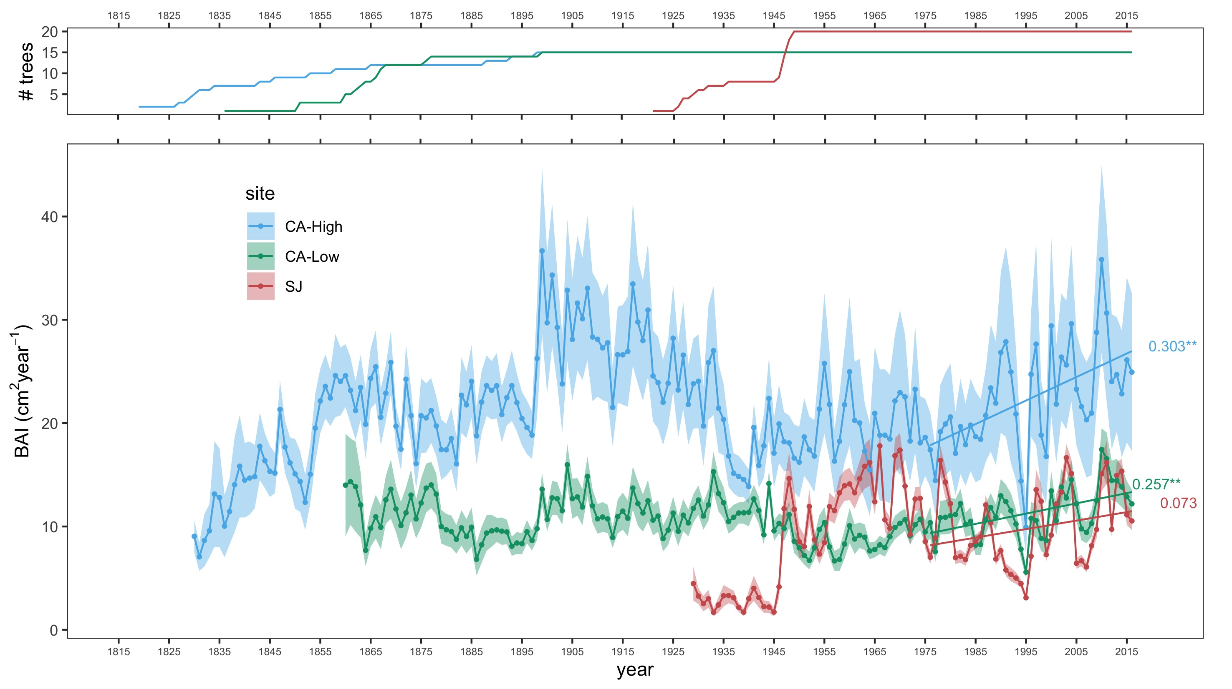

**Figure 4**

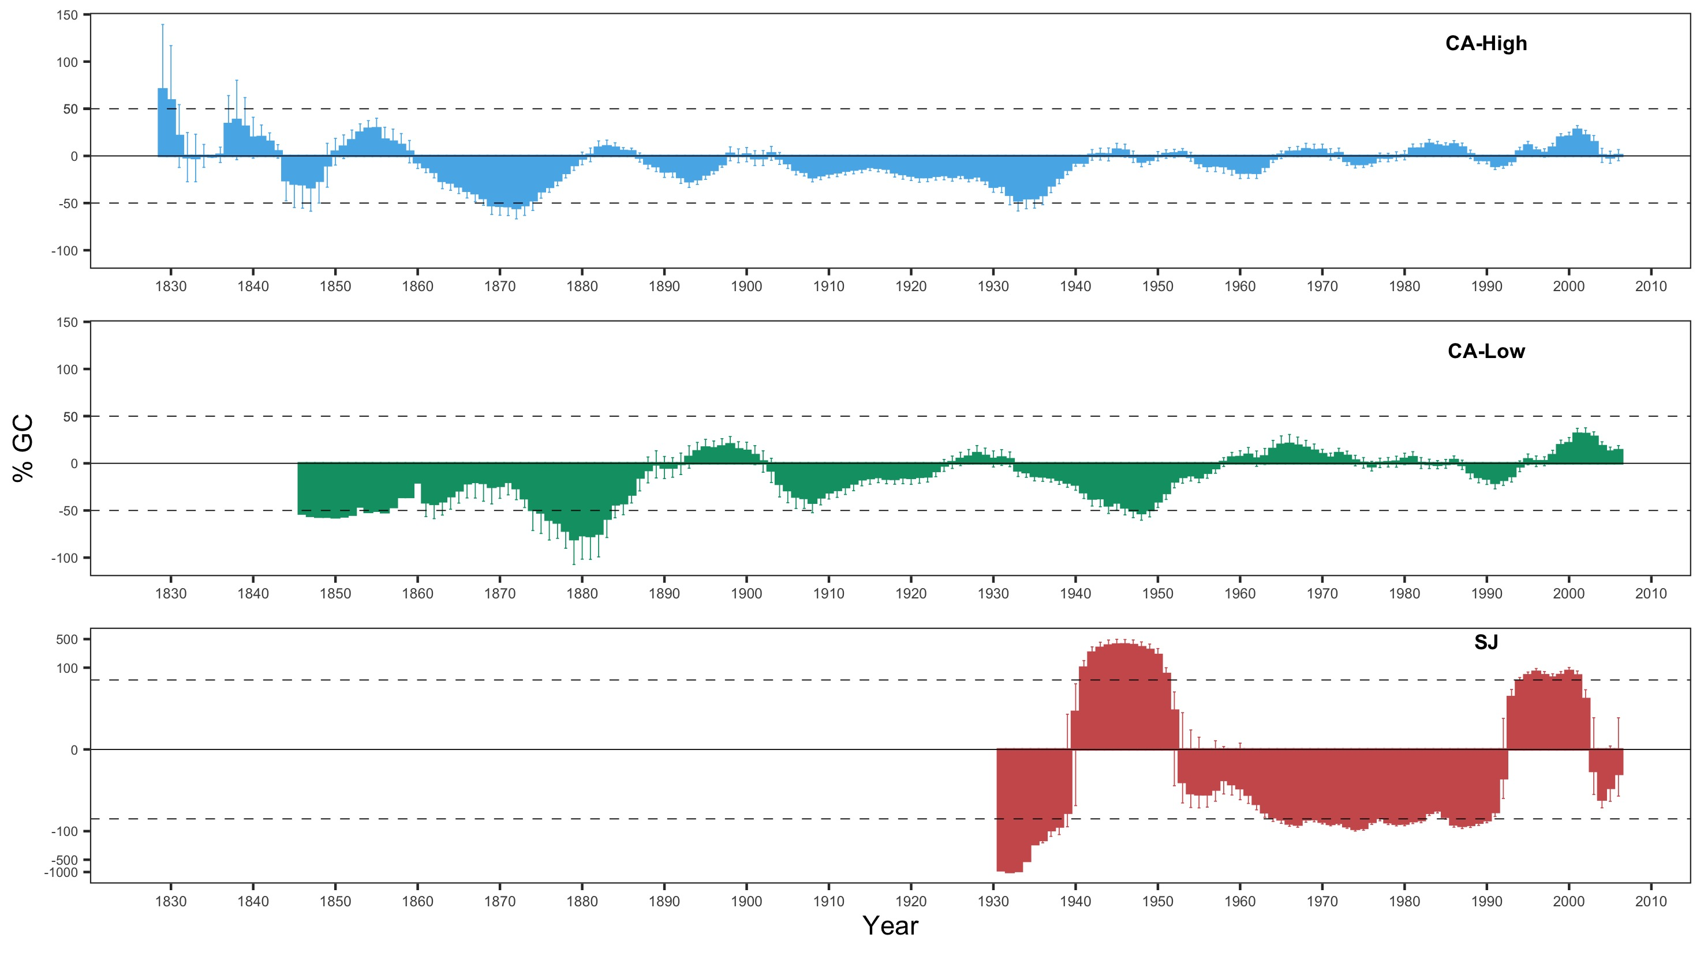

**Figure 5**

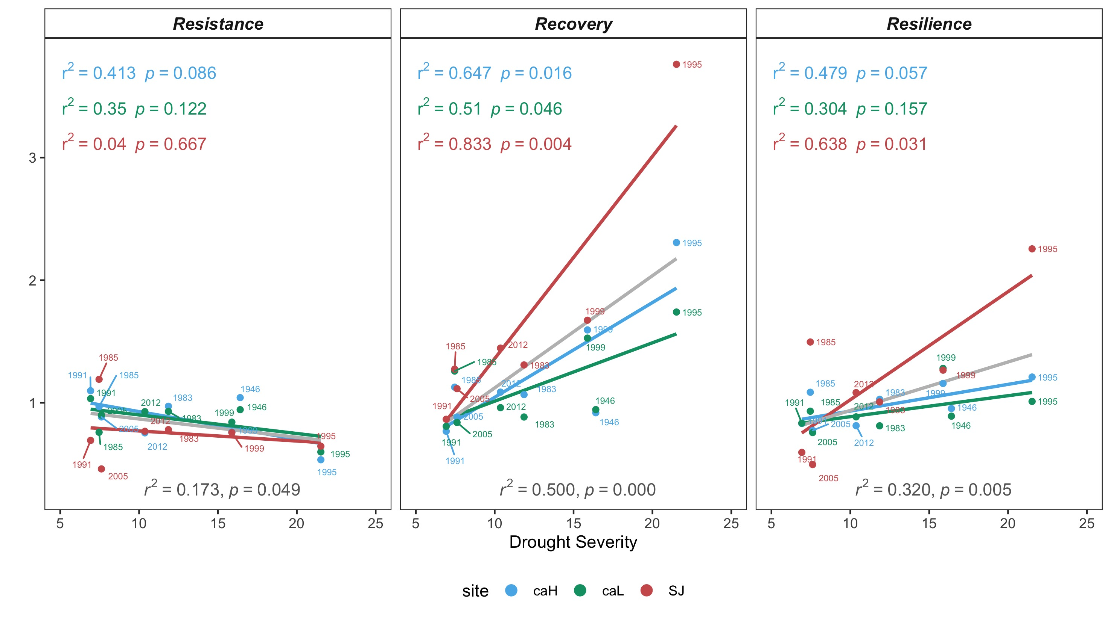

**Figure 6**

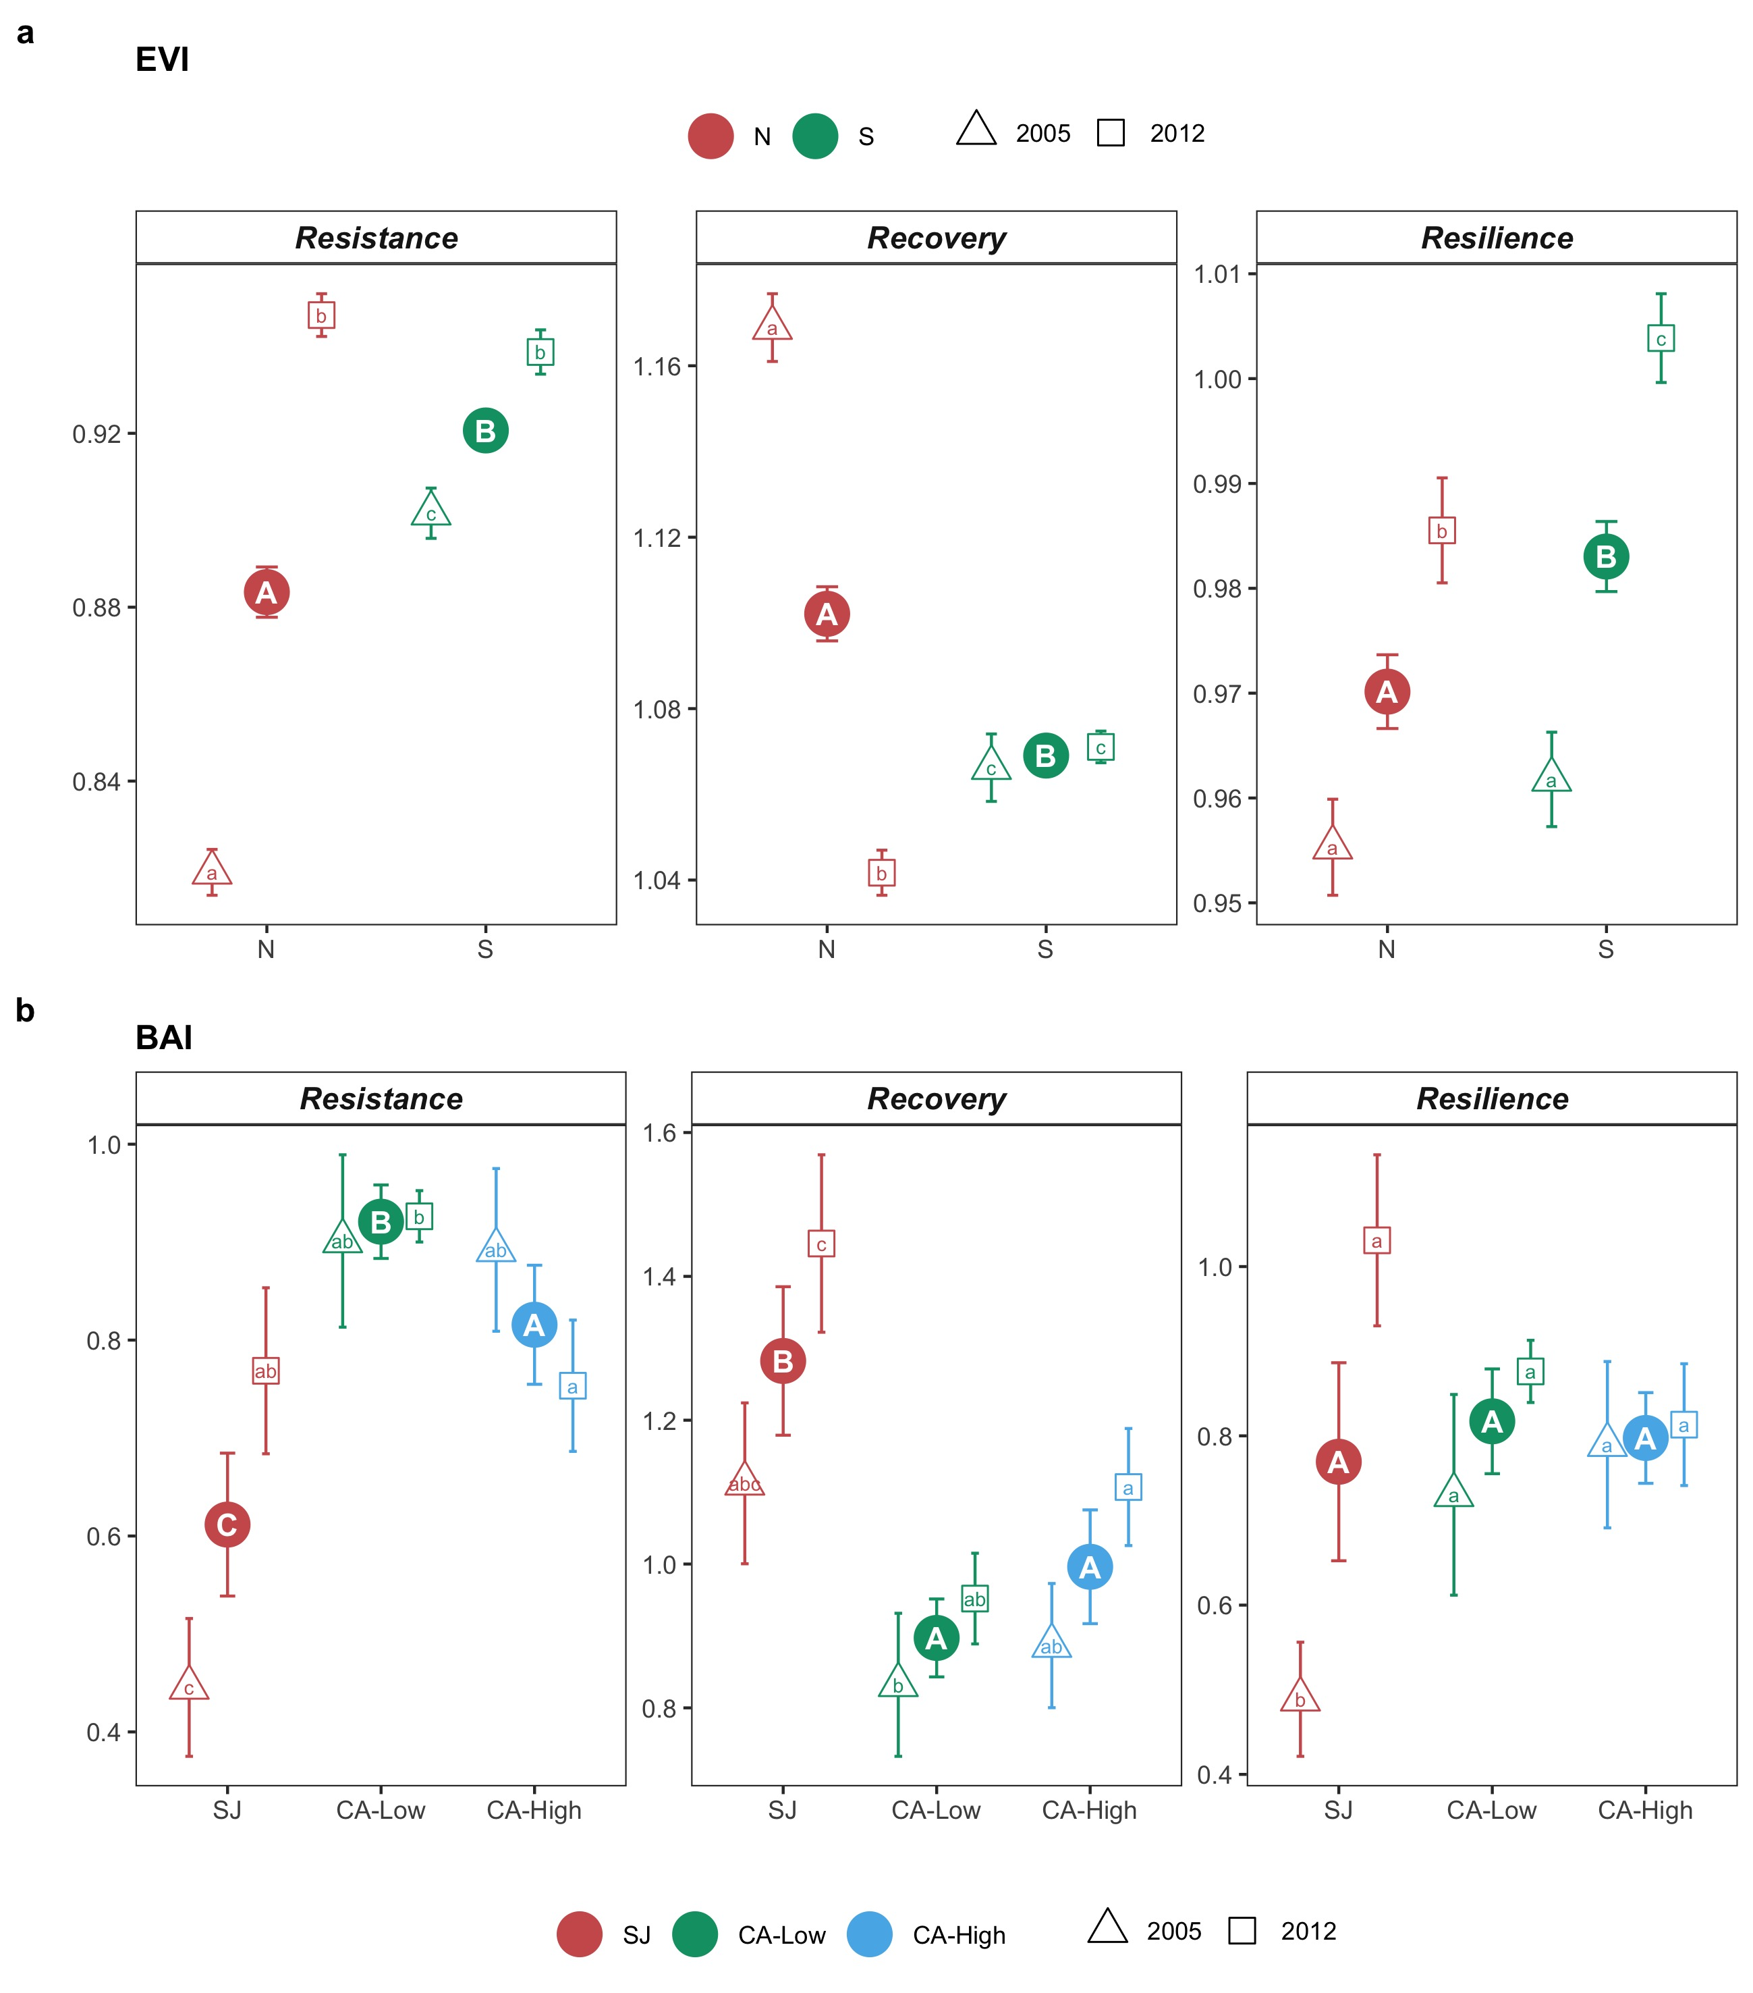

**Figure 7**

